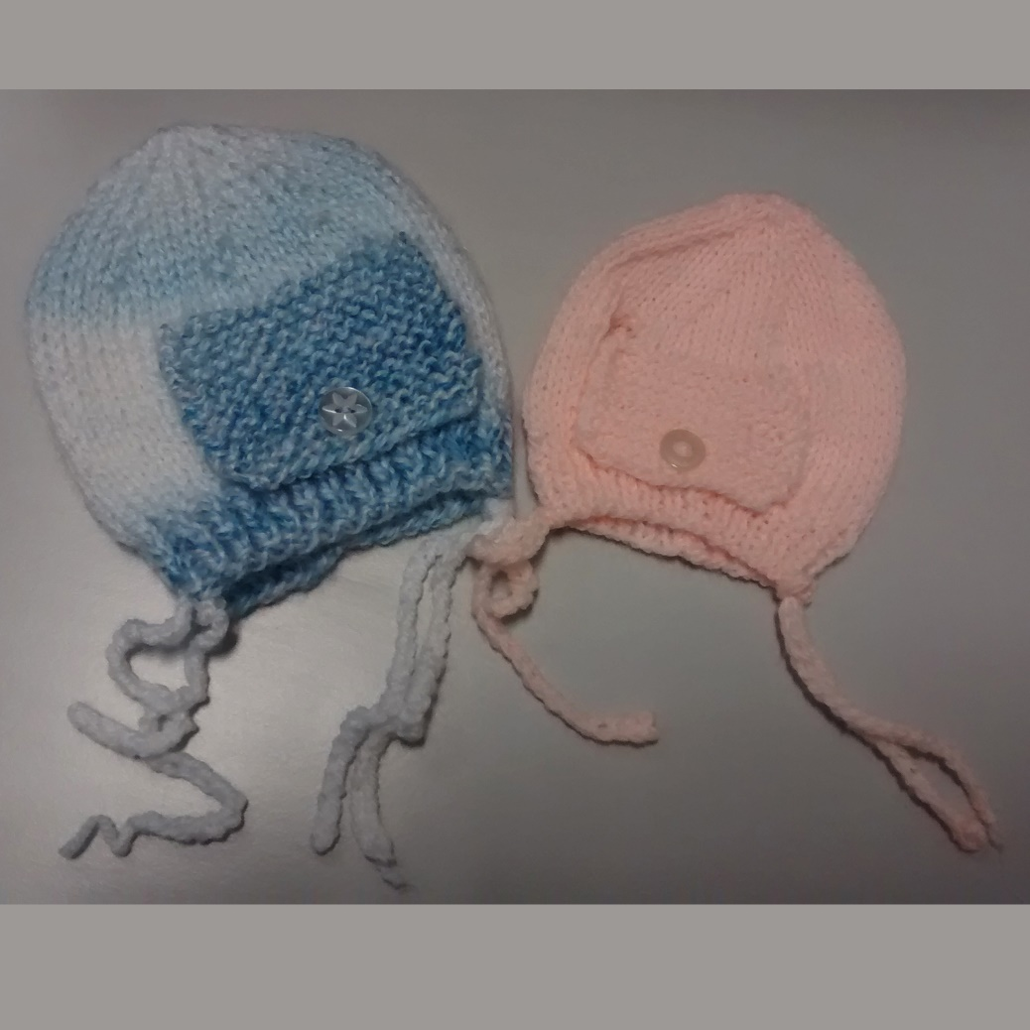Ventilator Bonnet Pattern
Thank you for volunteering to knit for the babies on St George’s neonatal unit, it is very much appreciated by the staff and the babies’ families. This little hat pattern is written in various sizes and wool. Please do not think that the smallest is too small. The 3ply version in particular is useful for very tiny babies.
3 ply, 2.75mm (no 12), 4 ply, no 3.25mm (no 10) D Knit, 4mm (no 8) Needles.

Knit Flap First
Cast on 15 stitches and work two rows in garter stitch (every row K) Next row: K7, Y FWD, K2 tog, K6.Next row: Work 14 rows in garter stitch,Next row: Cast off 2 sts, beg off next two rows. Leave remaining 11 stitches on a spare needle.

Bonnet
Cast on 53 (61, 69, 77, 85) sts, and work in 1 x 1 rib for 6 rows. Change to st st and work 2 (4, 4, 6, 8) rows.*
*NB: (on 1st row of these make a row of eyelet holes, i.e. knit 3 yfd K2 tog, repeat to end).
Next row: K21 (25, 29, 33, 37) sts, cast off 11 sts, K20 (24, 28, 32, 36) sts. Working on first 21 (25, 29, 33, 37) sts only, continue as follows:
1st row: P to last 2 sts, K22nd row: K
Repeat first and second rows 5 times, then first row once. Break off yarn and leave these sts on a thread (or on the needles). With wrong side facing rejoin yarn to remaining 21 (25, 29, 33, 37) sts and continue as follows:
1st row: K2, P to end2nd row: K. Repeat first and second rows 5 times, then first row once. Next row: K21 (25, 29, 33, 37) stitches. Knit 11 stitches from spare needle, knit across remaining 21 (25, 29, 33, 37) sts left on a thread. 53 (61, 69, 77, 85) sts. Next row: PWork 2 (4, 4, 6, 8) rows in st st.

Shape Crown
1st row: K7 (7, 8, 9, 9) sts *K2 tog, K5: rep from * to last 4 (5, 5, 5, 6) sts, K2 tog, K2 (3, 3, 3, 4) sts.2nd and every alternative row: P3rd row: K6 (6, 7, 8, 8) sts *K2 tog, K4: rep from * to last 4 (5, 5, 5, 6) sts, K2 tog, K2 (3, 3, 3, 4) sts.5th row: K5 (5, 6, 7, 7) sts *K2 tog, K3: rep from * to last 4 (5, 5, 5, 6) sts, K2 tog, K2 (3, 3, 3, 4) sts.7th row: K4 (4, 5, 6, 6) sts *K2 tog, K2: rep from * to last 4 (5, 5, 5, 6) sts, K2 tog, K2 (3, 3, 3, 4) sts.9th row: K3 (3, 4, 5, 5) sts *K2 tog, K1: rep from * to last 4 (5, 5, 5, 6) sts, K2 tog, K2 (3, 3, 3, 4) sts.11th row: K0 (0,1, 0, 0) sts *K2 tog, K1: rep from * to last 0 (1, 1, 1, 0) sts, K0 (1, 1, 1, 0) sts.
Break off yarn, run yarn through remaining stitches, draw up and then fasten off.
Knit 2 chain string/ties each approx 25cm/9 inches long.

To Make Up
Join all the way down back seam. Fold a tie in half and pass through knitting a couple of stitches up from the bottom on the side of the bonnet (see photos) and pass the free ends through the loop to secure the tie. Repeat on other side. The bigger holes you have knitted are for the hospital's use. Attach a small button to bonnet to fit button hole on flap.
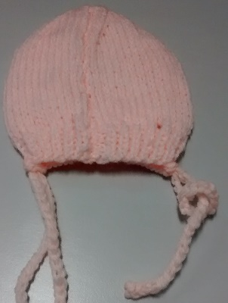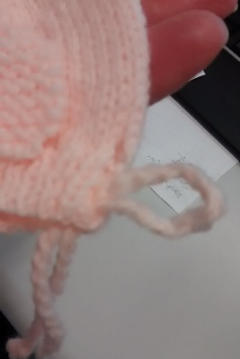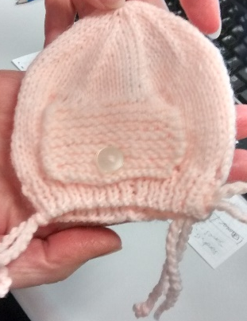

Note: This bonnet can be knit using 3 ply, 4 ply or Double Knit, please adjust needles to suit. If using DK the large size will be too big.

